L4U Build and Release Process

## Definitions

**[Development Folder]**

This folder contains the development code

*e.g. C:\L4U_Development\V12x_L4U_Enterprise_3_1*

**[Build Folder]**

This folder contains the following

* Applications - Build environment (4D)
* Source files – Build input
* Enterprise Builds – Build output
* Support Files – Images and other files
* --Plugins Base Set – base set of plugins for 4D
* XML files – “Makefiles” for the various platforms

*e.g. C:\OEM_V12_5*

**[Release Folder]**

The release folder name needs to be confirmed by the development manager

*\\Kelsoft-main\Development Share\Builds\[Release Folder_Name]*

## Required Information

See development manager for this information and write in for this build.

|  |  |
| --- | --- |
| **Release Date** |  |
| **Build Version Number** |  |
| **Release Folder Name** |  |

## Build Process

1. Compile your 4D code in the development environment and fix any errors.
2. 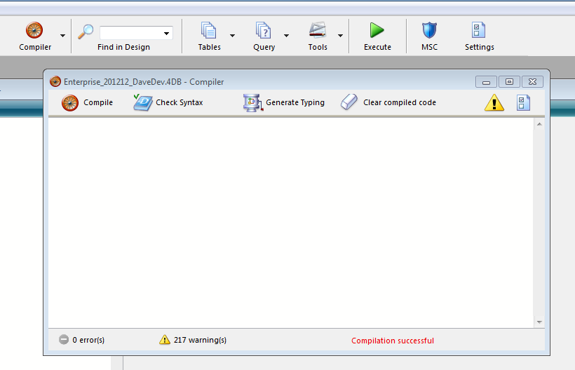Close your development environment
3. Copy Core 4D Files
   1. Copy your .4DB and .4DIndy files from your [Development folder] into

*[Build Folder]\Source Files*

* 1. Rename the resource file (.RSR) to match the name of the .4DB and .4DINDY files.

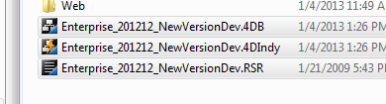

1. Open the project in the build environment
   1. Open 4D from [Build Folder]\Applications\4D\4D.exe
   2. Use File -> Open and select the 4DB file
   3. Login as you would in developer mode
2. Set the Build Information.
   1. Edit the ***aaaBuildNameDate*** method and:
      1. Write down the current information
      2. Set **<>SoftwareReleaseDate** to the current date
      3. Set **<>InternalVersion** to the official release name (see development manager)

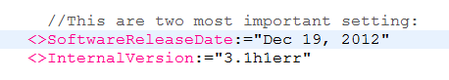

1. Compile and Build the application
   1. Run the ***aaaBuildApplication*** method:
      1. Right-click and select “Run Method”
      2. 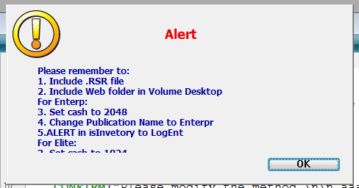An alert will popup - Click Ok
      3. 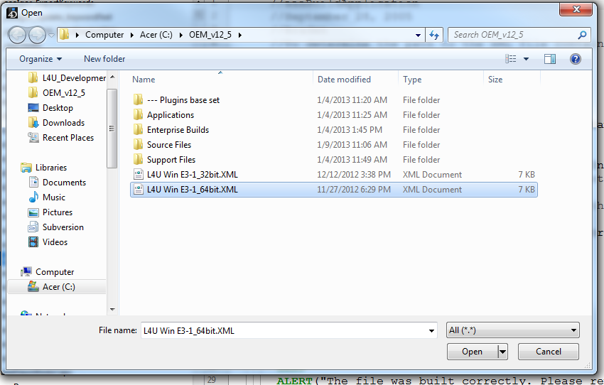While building you will be prompted for a “Makefile”

Select the file e.g. *[Build Folder]\L4U Win E3-1_[platform].XML and press “open”*

* 1. 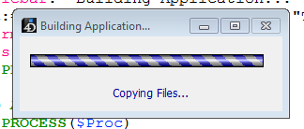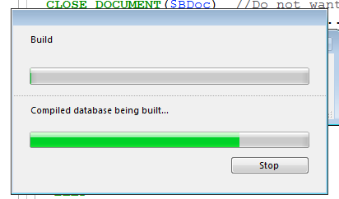The application will build
  2. If there are any errors reported

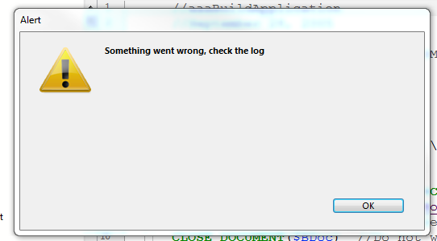 check the log file at *[Build Folder]\Source Files\Logs\L4U Win E3-1_[platform].log.xml*

* 1. 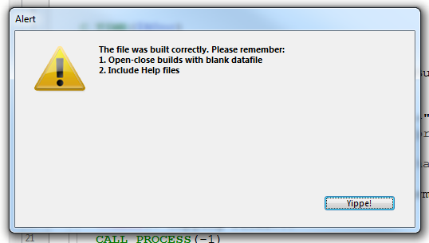If successful

You can find the build files in *[Build Folder]\Enterprise Builds\[platform]*

There should be the following folders:

* Final Application
* Compiled Database
* Client Server Executable\L4U Enterprise Client
* Client Server Executable\L4U Enterprise Server

1. 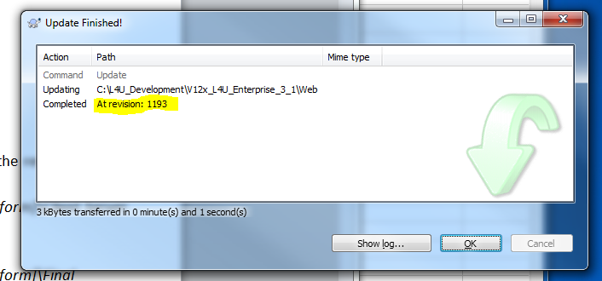Update the Web Folders
   1. Update the Web folders in your [Development Folder] from Subversion and note the revision id.
   2. Delete all files from the following folders:

*[Build Folder]\Enterprise Builds\--- Data to copy after building - WEB\[platform]\Client Server executable\L4U Enterprise Server\Server Database\Web*

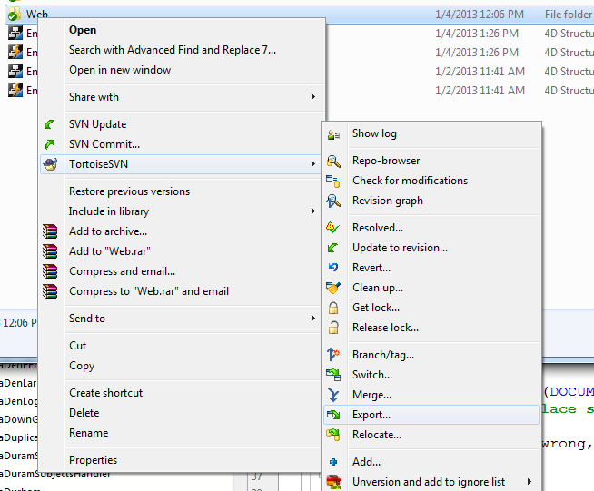*[Build Folder]\Enterprise Builds\--- Data to copy after building - WEB\[platform]\Final Application\L4U Enterprise\Database\Web*

* 1. Export the web folder content from [Development Folder]\Web to the two folders above using the SVN command “Export”.
  2. Launch the “Advanced Find and Replace” utility and update the revision number for all files within two folders above by doing a find for:

*<!--SVN_Revision_Begin-->.*<!--SVN_Revision_End-->*

And replace with

*<!--SVN_Revision_Begin-->[REVISION #]<!--SVN_Revision_End-->*

* 1. Also replace:

*<!--TT\d{3}-->*

With an empty string

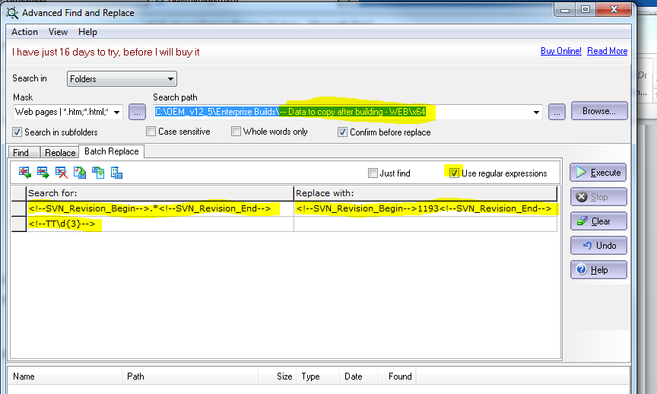

* 1. Copy the exported web folder to the built application folder:

*[Build Folder]\Enterprise Builds\--- Data to copy after building - WEB\[platform]\\**

To

*[Build Folder]\Enterprise Builds\[platform]*

Select “Merge Folder” if prompted

1. Update add-on components.
   1. Copy

*[Build Folder]\Enterprise Builds\---Data to copy after building\[platform]\\**

To

*[Build Folder]\Enterprise Builds\[platform]*

Select “Merge Folder” if prompted

* 1. To save space, delete all folders except **4DInternetCommands** from:

*[Build Folder]\Enterprise Builds\[platform]\Client Server executable\L4U Enterprise Client\Plugins*

1. Create the archive files for these folders:

* *[Build Folder]\Enterprise Builds\[platform]\Final Application*
* *[Build Folder]\Enterprise Builds\[platform]\Client Server executable\L4U Enterprise Client*
* *[Build Folder]\Enterprise Builds\[platform]\Client Server executable\L4U Enterprise Server*

For each folder:

* 1. Right-click and select “Add to archive…”

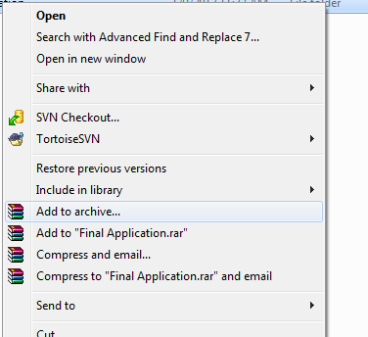

* 1. Select “Create SFX archive” when asked.

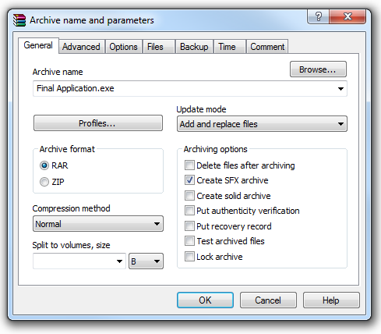

* 1. Save the result at the same level as the original folder

## Release Process

1. Create the [Release Location] if it does not exist
2. Rename the 3 .exe files (archives) that were created earlier as follows

* *Final Application.exe -> L4U_Ent_SU_[Build_Version_Number].exe*
* *L4U Enterprise Client.exe -> L4U_Ent_Client_[Build_Version_Number].exe*
* *L4U Enterprise Server.exe -> L4U_Ent_Server_[Build_Version_Number].exe*

1. Update the Release Notes
   1. Open

[Build Folder]\Enterprise Builds\[platform]\readme_[OLD_Build_Version_Number].docx

* 1. Change the notes as required
  2. Start the newly built server application and use a web browser to go to the L4U web interface
  3. Take a snapshot of the L4U version and highlight the L4U Release Number and the web folder SVN Revision number and paste it into the release notes. For example

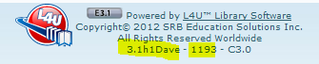

* 1. Copy the updated release notes to

[Release Folder]\readme_[Build_Version_Number].docx

* 1. Place a copy of the release notes in Evernote
  2. Paste the release notes into an email to Denys and send
  3. Add the release notes to the the Google Docs file L4U Enterprise Release Notes